Apple Authorized Training Center

Policies and Practices



Table of Contents
General Information 5
1. Apple Sales Web (ASW) Access 5
2. Changes to this document 5
3. Training Classes 5
a. Authorized Training Locations 5
c. Minimum Number of Training Classes 6
d. Enrollment of Students 6
e. Certified Trainers 6
f. Classroom 6
g. Software 6
h. Method of Delivery 7
4. Co-Marketing 7
5. Duties of Training Center 7
a. Schedule of Training Classes 7
b. Forecasting Demand 7
c. Registration 7
d. Customer Billings 8
e. Student Roster 8
f. Completion Certificates 8
6. Materials 8
a. Student Course Materials Orders 8
b. Instructor Course Material 9
c. Return Policy on Student Course Material 9
d. Copyright Notice 9
e. Apple Proprietary Materials 9
f. Apple Course Curriculum 10
g. Distribution of Apple Course Materials 10
h. Prices 10
i. Payment Terms 10
7. Performance of Training Center 10
a. Evaluation Forms 10
b. Monitor Performance 10
c. Quality Assurance Remedies 10
8. Cancellation 11
a. Customer Cancellation 11
b. Training Center Cancellation 11
Minimum Facility Requirements Document 12
Minimum Classroom Recommendations for any Apple course taught 12
Minimum Projection System Requirements 12
Minimum Network Requirements 13
Minimum Student System Requirements 13
Minimum Instructor System Requirements 13
Minimum Software Requirements for both Students and Instructor 13
Clockwork Scheduling System: An Introduction 21
Required Clockwork Setup for AATCs 21
Scheduling Classes in Clockwork 22
Step 1. Log In 22
Step 2. Select Master Schedule Link 22
Step 3. Identify Range of Weeks to Schedule 23
Step 4. Schedule A Proposed Class Draft 23
Step 5. Change Class Status from Draft to Committed 23
Step 6. Submit Schedule for Publishing 24
Step 7. Log Out 24
Canceling A Class 26
Canceling Class In Draft or Committed Status 26
Canceling A Published Class 26
Clockwork Glossary 27
Winona Ordering System: An Introduction 28
Required Winona Setup 28
Preparing to Order Materials 28
Frequency, Timing & Shipment Guidelines 28
Ordering Form Escalation 28
Ordering Training Materials 29
Step 1. Log In 29
Step 2. Access Winona 29
Step 3. Access the Apple Training Materials Order Form 29
Step 4. Input Quantity and Select Shipping Method 30
Step 5. Add Shipping and Payment Information; Place Order 31
Step 6. Order Confirmation 32
Step 7. Shipment Confirmation 32
Resolving Order Problems 33
Possible problems / Who to contact 33
Resolving Access Problems 33
Materials Ordering Glossary 36
Training Units 1.5 Business Processes 37
Training Units Redemption for Class Registration at AATC 38
Credit Process for When Customer Calls to Cancel Class at an AATC 39
Credit Process for when AATC Cancels Course at their Location 40
Payment Process for AATC redemption of Apple Training Units 41
Apple Authorized Training Center Training Units Process Acceptance Form 42

General Information

Apple Sales Web (ASW) Access
ASW is Apple's channel web site. You will find policies, practices, and other valuable tools necessary for doing business with Apple. As an Apple Authorized Training Center, you are required to access this site on a weekly basis. You need an AppleConnect ID in order to access the site. If you do not have access to ASW or an AppleConnect ID, please follow the instructions below to register for ASW.

TO REGISTER FOR ACCESS
- Go to http://sales.apple.com
- Click the "register here" link located in the top, right hand corner of the log in screen. Please complete the form, including the Apple ID for your location. Submit the registration form.
- You will receive a confirmation email within 3 business days.
If you have any questions or problems with your registration, please contact: asw@apple.com.

Changes to this document
Apple reserves the right to change the Policies and Practices Document, at any time, by posting to Apple Sales Web and notice shall be deemed given when posted, and Training Center shall have a commercially reasonable period of time to implement any notified changes on the Training Class, provided such period shall not exceed thirty (30) days.

Tiered AATC Program
TIER 0 | TIER 1
No Annual Fee | $2500 Annual Fee
Class materials for purchase at 35% of retail price of class. | Class materials for purchase at 30% of retail price of class up to $35,000 within the calendar year.  For additional materials purchased in calendar year over $35,000, materials will be purchased at 25% of retail price of class.
Access to AATC signature.  Signature subject to repeal if less than 2 classes held per quarter. | Access to AATC signature.  Signature subject to repeal if less than 1 class held per quarter.
No listing on WWCT Website | Listing of facility and training schedule on WWCT website
 | First priority for access to Train-the-trainer (T3) sessions and trainer readiness materials
AATC trainers are given priority for teaching Apple customer onsites.

Customer requests for a particular trainer and Apple Badged Trainers take priority over AATC trainers.

Training Classes
The Training Center is permitted to deliver only the Training Classes that are associated with the Apple Course Material that it is authorized to distribute. Apple reserves the right to change the Training Class title and content, at any time, by posting to Apple Sales website and notice shall be deemed given when posted, and Training Center shall have a commercially reasonable period of time to implement any notified changes on the Training Class, provided such period shall not exceed thirty (30) days.

Authorized Training Locations
Apple Courses must be held at Training facilities that meet Apple's Minimum Facility Recommendations and Requirements as outlined in this document. Additionally, Apple reserves the right to inspect all Authorized Training Center Locations, prior to authorization or anytime thereafter to confirm that the location complies with the requirements. Upon submission of a completed application form and the relevant application fee, the Training Center may request that additional locations be authorized under this Agreement. Based on the location's compliance with the requirements and any inspection performed by Apple, if any, Apple will determine in its sole discretion whether the location is authorized, and shall confirm its approval in writing.
    - Business or Government Customer Onsites
Training Center is able to deliver at business or government customer locations
      - Must have a minimum of 6 and maximum of 16 students
      - Submit roster on first day of class with each student classified as an open enrollment student.
    - Education Customer Onsites
Training Center should check with the AATC Program Manager.

Minimum Number of Training Classes
Training Center agrees to deliver a minimum of one (1) Apple technical training class each quarter in order to maintain a presence on Apple’s training website, http://train.apple.com.

Enrollment of Students
Subject to the terms of the Agreement, the parties agree that the Training Center is authorized to deliver Training Classes at Authorized Training Locations where student enrollment is available to any member of the general public (“Open Enrollment”) or when student enrollment is restricted to private groups ("Closed Onsite") at Training Center’s location.

Certified Trainers
Unless otherwise agreed to by Apple, only employees or authorized independent consultants of the Training Center who are Certified Trainers are permitted to deliver Training Classes under this Agreement. Details on Apple’s Certified Trainer Program are currently available at http://train.apple.com. Certified Trainers may not deliver Training Classes for which they are not certified. The Training Center shall ensure that each Certified Trainer remains in compliance with Apple's Policies and Practices for Apple’s Certified Trainer Program while delivering Training Classes.

Classroom
Each Training Class must be held in a classroom located within an Authorized Training Center Location that meets or exceeds the requirements described in the Minimum Facilities Requirements Section of this document.
    - Apple specifies a maximum number of sixteen (16) students who may attend a Training Class, and the Training Center agrees not to exceed the stated maximum.
    - Each Classroom will have sufficient equipment to allow each student to use individual equipment, (and not share) through the duration of a Training Class.

Software
Training Center will provide the appropriate software to run each Training Class, as specified in the minimum facilities requirements portion of this document and shall purchase as required valid software licenses from Apple or any third party vendor for all computer systems used by Certified Trainers and Students participating in the Training Class in the classroom, including updates that may be required. Existing Apple Software licenses for the Authorized Training Locations may be used so long as each Student and Certified Trainer station is individually licensed and the version complies with the CRD requirements. Training Center agrees to comply with all licensing terms of the software required in delivering Training

Method of Delivery
The Training Center agrees that the method of delivery and technical discussions of the Apple Course Materials shall be based on those demonstrated to Certified Trainers during the Apple Certified Trainer Train-the-Trainer (T3) Program. Class discussions and laboratory exercises will be consistent with those defined in the Apple Course Materials.

Co-Marketing
- Training Center may include descriptions of Training Classes that Training Center is authorized to deliver in its relevant training and promotional publications such as course catalogs websites, and various marketing material
- All course catalogs, promotional publications and other materials promoting Training Classes offered by the Training Center must be reviewed and approved by Apple in writing before publication to ensure Apple’s third party guidelines on trademark use are being met. Apple will use reasonable efforts to review publications within a commercially reasonable period of time not to exceed thirty (30) days.
- An annual marketing fee per AATC location will be assessed for placement of AATC on the Apple Customer Training website and for the ability to post schedules online for customer viewing. This fee will also give the Training Center reduced pricing on class materials and other program benefits. This is an optional fee and covers only the calendar year in which it is paid. All participating AATCs will be assessed a new marketing fee each January, regardless of the month in which they paid the previous year’s fee.

Duties of Training Center

Schedule of Training Classes
Within thirty (30) days after execution of this Agreement, the Training Center shall submit to Apple on a weekly basis its proposed schedule of Training Classes to be delivered at each Authorized Training Location during the following ninety (90) days. At Apple's discretion, all Open Enrollment schedules may be advertised by Apple on its website, provided Training Center delivers such information to Apple at least ninety (90) days in advance of any Training Class. Apple will not be responsible for any errors made by Training Center's regarding their schedule of Training Classes.

Forecasting Demand
Training Center will provide to Apple each Monday a ninety (90) day forecast of Apple Student Course Material demand and will promptly notify Apple if additional Training Classes are scheduled for commencement during the next ensuing ninety (90) days. Each forecast will contain the dates, locations and expected or known fill rate for the scheduled Training Classes.

Registration
Apple and the Training Center agree that throughout the term of the Agreement Training Center is responsible for registering Students seeking enrollment in Training Classes delivered by Training Center. Training Center is responsible for administering the cancellation policy.

Customer Billings
Apple and Training Center agree that Student billing for the Authorized Training Location will be handled by Training Center in the same manner as other customer billing activities. Training Center shall be responsible for handling all Training Center inquiries and complaints concerning billings, unless agreed otherwise in writing by both parties.

Student Roster
On the first day of each Training Class, Training Center agrees to complete and forward to Apple a complete student roster of attendees at such Training Class via the Roster Tool autowizbot@apple.com with a cc to trainingcenter@apple.com via email transmission and/or facsimile at 408-974-2176 or as otherwise directed by Apple. Student Roster information should include the Course Part Number, Date of Class, Instructor's Name, Student’s name, company, and full company address. Any Apple Training Unit customers should have a Pre-Authorization ID number submitted on the Roster as well. Apple may terminate the Training Center's authorization immediately if the Training Center fails to adhere to the requirements of the Student Roster.
    - Privacy Of Student Data - Training Center agrees to comply with all laws regarding the gathering, compiling and distribution of information relating to the personally identifiable information of Students, including if appropriate, notice prior to or at registration that personally identifiable information may be shared with other third parties for evaluation, marketing and administration purposes. Training Center must indicate on the Student Roster whether Students have not permitted Training Center to allow their personal identifiable information to be processed in this way.

Completion Certificates
The Certified Trainer must provide each Student who completes the Training Class a Course Completion Certificate on the last day of the Training Class. The Course Completion Certificate must be in accordance with Apple's Corporate Identify Guidelines.

Materials

Student Course Materials Orders
Student Course Materials must be ordered through Apple’s online Material Ordering System which may be accessed at the Apple Sales web site at: http://asw.apple.com.
    - Student Course Materials should be ordered on a weekly basis or as otherwise needed. It is recommended that orders should be placed ten (10) business days in advance of class start date to meet on-time delivery. Apple is not responsible for delays in shipment.
    - Training Center is responsible for all shipping charges.
    - Once Apple accepts an order, it cannot be canceled.
    - An email order confirmation will be sent when an order is received.
    - Apple accepts MasterCard, Visa, or American Express as methods of payment. A pre-approval from the credit card company is obtained at the time an order is placed. Credit card billing occurs when the order ships.
    - Student Course Materials will only be shipped to Authorized Training Center locations.
    - A shipment confirmation will be sent via email when the order ships.
    - Detailed instructions on how to order are provided in this document.

Instructor Course Material
Apple will provide at no charge to Certified Trainer one set of Instructor Course Materials per course required to deliver Training Classes, as corresponding Student Course Materials orders are received from Training Center. Any lost or replacement materials must be replaced at the expense of the Certified Trainer.

Return Policy on Student Course Material
Except as provided in this section, Apple shall not accept any returns of Apple Course Material.
- Subject to Training Center’s compliance with the terms and conditions of the Agreement and the conditions stated below, Training Center is permitted to return Student Course Material following a major content revision of a Training Class. Apple, at its sole discretion, will determine major revisions. Return of Apple Course Material is limited to the following conditions:
      - Training Center is permitted to return up to three (3) sets per course of Student Course Materials after notification by Apple of a major Training Class content revision (e.g., v10.2 to v10.3) in exchange for Apple shipping an equal number of sets for the revised Training Class.
      - The return of the Student Course Material sets must take place within sixty (60) days of notification by Apple of the revised Training Class.
      - Student Course Material must be returned to Apple at Training Center's expense before Apple will ship updated Student Course Materials.
      - Student Course Material must be returned unused and in its original packaging. No credit or price adjustments will be provided for returned Student Course Material.
      - Apple reserves the right to modify its returns policy for Student Course Material in the event that a material change occurs for a particular Training Class.

Copyright Notice
It is the responsibility of Training Center to make reasonable efforts to make Students aware of the copyright notice contained within the Student Material.

Apple Proprietary Materials
Training Center shall perform Training Services using only Course Materials determined by Apple. Training Center shall provide one set of Student Course Materials for each Student enrolled in the Training Class and will not use any other materials, unless otherwise agreed in writing by Apple.

Apple Course Curriculum
Training Center will not alter, add to or delete from, or teach part of the course curriculum, Instructor or Student Course Material presentation slides at any time without prior written authorization from Apple.

Distribution of Apple Course Materials
Training Center is not authorized to provide copies of Apple Course Materials to any person not enrolled in the Training Class. Training Center may subject itself to infringement action if it distributes or permits the use of Apple Course Material not authorized under this Agreement.

Prices
The pricing for Training Center’s Apple Course Material is set forth in the Authorized Apple Course Materials Price List located on ASW.

Payment Terms
All materials will be ordered via Winona on Apple Sales Web and payment made via Training Center’s credit card. The only exceptions allowed will be for special promotions. Any invoices for these promotions will be payable within 30 days from the date of invoice or all future orders will be held until such payment is received in full.

Performance of Training Center

Evaluation Forms
On the last day of each Training Class, Training Center agrees to provide to Students the class evaluation forms and to gather completed forms and forward them to Apple via email transmission to abouttraining@apple.com within five (5) business days thereof or as otherwise directed by Apple.

Monitor Performance
Following receipt of the class evaluation forms, Apple will review the forms for quality assurance purposes. If any Certified Trainer receives an overall score for a Training Class that is less than the Quality Assurance Threshold set for the Training Class as described in the Authorized Apple Course Materials and Price List, Apple may terminate the Agreement in accordance with its terms or pursue such other remedies in its sole discretion, including but limited to the Quality Assurance Remedies described below.

Quality Assurance Remedies
In the event that Training Classes are not performed in a manner consistent with the provisions of this Agreement, Apple may request that the situation be cured.
    - Upon receipt of notice, Training Center and Apple will jointly develop and implement an action plan to remedy the situation within thirty (30) days.
    - If the situation is not corrected within a total of forty-five (45) days after notification of the problem, or within a reasonable length of time as dictated by the agreed-upon action plan, Apple may after reasonable consultation with Training Center, direct Training Center to take additional corrective action.
    - If a replacement Certified Trainer is required, Training Center shall bear the costs associated with replacing a Certified Trainer.
    - If problems persist beyond an additional remedial action time limit of forty-five (45) days, Apple reserves the right to terminate the Agreement immediately. This right to terminate is in addition to any other rights Apple may have under the Agreement.

Cancellation
The parties agree that the following cancellation policy shall apply to all Training Classes delivered by Training Center:

Customer Cancellation
    - Customer is entitled to full refund if written notice is received at least 14 days in advance of the class.
    - Customer is entitled to a full class credit if written notice is received at least 7 days in advance of the class. Class credit must be used within 6 months of the date of the original class at another class offered by Training Center.
    - Customer is not entitled to a refund or class credit if less than 7 days advance written notice is given.
    - Failure to provide written notice at least 14 days in advance of the class obligates the Customer to pay the full price of the class.

Training Center Cancellation
    - Training Center reserves the right to amend or cancel the date, time and location of a Training class at any time, including replacing personnel who may be scheduled to deliver the Training.
    - In the event a Training class is cancelled by the Training Center, the Customer is entitled to a full refund.
    - Training Center shall not be responsible for any other loss incurred by Customer as a result of a cancellation or amendment.
    - Training Center shall immediately notify Apple by fax at 408-974-2176 or email at trainingcenter@apple.com of any cancellation of a Training Class by Training Center.
    - If the Authorized Training Location is available for the Training Class at the scheduled time and another trainer certified by Apple is available to teach the Training Class at the Authorized Training Location at the scheduled time, with the consent of Training Center, Apple may facilitate the attendance of such trainer to teach the Training Class, and shall invoice Training Center the trainer’s fees and reasonable expenses for delivering the Training Class. Payment shall be due thirty (30) days from Apple’s invoice date.
    - If the Authorized Training Location is not available at the scheduled time, in addition to immediately notifying registered Students of the cancellation, Training Center will make commercially reasonable efforts to reschedule the Apple Course at the Authorized Training Location at a time and date closest to the original schedule.

Minimum Facility Requirements Document
This document provides details about minimum facility requirements broken out by Apple courses.
- The Training Center is responsible for maintaining the Minimum Facility Requirements and is responsible for providing all hardware and software described in this document; for each classroom, network, and projection system setup; and for installing the software prior to the first day of class.
- The Certified Trainer must have access to the classroom at least one business day prior to the first day of class. It is recommended that throughout the Apple Course, the Certified Trainer have easy access to the classroom, including after-hours and weekends.

Minimum Classroom Recommendations for any Apple course taught
- Minimum recommended classroom size is 40-feet by 40-feet.
- Student work surfaces should be at least 36 inches wide by 28 inches deep, to accommodate two student systems.
- The instructor's table should be at least 48 inches wide by 28 inches deep, and located at the front of the classroom.
- Armchairs are recommended for all students and the instructor. Padded seats are preferred.
- Power outlets need to be provided for all computers, monitors, and peripheral devices used in the class, and should provide approximately five (5) amps of power for each device.
- The projection screen at the front of the classroom should be at least seven (7) feet away from the nearest edge of the student tables.
- Lighting controls should be accessible by the instructor. Dimming capability is preferred.
- Temperature controls should be accessible by the instructor.
- A wall-mounted or freestanding white board (with dry-erase markers and erasers) is suggested and should be located at the front of the classroom.
- A Mac OS X-compatible USB raster printer (with appropriate interface cable) with 10 foot cord is needed and should be accessible to the instructor.
- The classroom should be free of noisy machinery so the instructor can converse with students comfortably.
- Phones and restrooms should be easily accessible.
- One 100BASE-T Ethernet switch with n+5 or more ports (where n=number of students)
- Projection system (as defined below)

Minimum Projection System Requirements
- The projection equipment needs to be on a sturdy table or stand (approximately 29 inches high), or ceiling mounted.
- Minimum requirements for the projection system are as follows:
  - Resolution of 1024 by 768 pixels @ 75Hz
  - Projection rating of at least 2,000 lumens
  - 6 x 6 foot or larger projection screen
  - Spare projector bulbs
  - VGA switchbox
  - 3-port Switchbox capable of allowing projection from either Instructor System
  - Appropriate cables to connect the switchbox to the projection system
  - Cabling to simultaneously connect two monitors to the switchbox

Minimum Network Requirements
- Each student station should be isolated from any other customer or classroom network, on a separate 100-Mbps Ethernet switch with n+5 or more ports (where n=number of students).
- Network must be isolated from any other customer network.
- All machines should be networked and have their connectivity tested prior to the first day of class
- Internet access or local subnet setup for all systems
- Optional - Airport

Minimum Student System Requirements
- Each student station should consist of one computer system, a client system, along with a 4-port 100-Mbit hub.
- One dedicated student station must be provided for each student in the class. Because systems will be re-imaged before the start of class, provide only systems whose hard drives can be erased.
- Macintosh computer with PowerPC G3, G4, or G5 processor with built-in USB
- Display with 1024 by 768 pixels, 16-bit resolution
- 128 MB of physical RAM (256MB RAM preferred)
- 2GB available hard disk space (4GB hard drive preferred)
- DVD-ROM
- 100BASE-T Ethernet
- Optional – Airport card

Minimum Instructor System Requirements
- Each instructor station should consist of two (2) computer systems; a client/presentation system and a server system, along with a 4-port 100-Mbit hub.
- One dedicated instructor station must be provided for each classroom. Because systems will be re-imaged before the start of class, provide only systems whose hard drives can be erased.
- Macintosh computer with PowerPC G3, G4, or G5 processor with built in USB
- Display with 1024 by 768 pixels, 16-bit resolution
- 128 MB of physical RAM (256MB RAM preferred)
- 2GB available hard disk space (4GB hard drive preferred)
- DVD-ROM
- 100BASE-T Ethernet
- Optional – Airport card

Minimum Software Requirements for both Students and Instructor
- One copy of Mac OS X v10.3 installed (use clean default easy install), including NetBoot, is required for each student and Instructor station for all Mac OS X courses.
- It is the responsibility of the Training Center to ensure valid software licenses from Apple or any 3rd party vendor for all computer systems used by Training Center for students and Instructors participating in the specific Apple Course, including updates that may be required.

MacOS 100 Introduction to Mac OS X v10.4 for Technical Professionals

Minimum Classroom Recommendations for any Apple course taught – All minimum requirements listed above, plus:
- Eight FireWire cables (6-pin to 6-pin, male to male, 3 feet long).
- Optional – Six USB Bluetooth transceivers

Minimum Student System Requirements- All minimum requirements listed above, plus:
- Built-in FireWire port

Minimum Instructor Systems Requirements- All minimum requirements listed above, plus: The instructor systems include one machine from which to display the slides and demonstrate Mac OS X and one machine, which acts as a classroom server to demonstrate Mac OS X Server.

Instructor System 1
- Macintosh v10.4-compliant G4 or G5 computer
- Video output for connection to projector
- 256MB RAM
- 4GB hard drive
- AirPort Card installed
- Network access to both classroom network and Internet

Instructor System 2
- Macintosh v10.4-compliant G4 or G5 computer
- Video output for connection to projector
- 256MB RAM

4GB hard drive

MacOS 101 Mac OS X v10.4 Support Essentials

Minimum Classroom Recommendations for any Apple course taught – All minimum requirements listed above, plus:
- Eight FireWire cables (6-pin to 6-pin, male to male, 3 feet long).
- Optional – Six USB Bluetooth transceivers

Minimum Student System Requirements- All minimum requirements listed above, plus:
- Built-in FireWire port

Minimum Instructor Systems Requirements- All minimum requirements listed above, plus: The instructor systems include one machine from which to display the slides and demonstrate Mac OS X and one machine, which acts as a classroom server to demonstrate Mac OS X Server.

Instructor System 1
- Macintosh v10.4-compliant G4 or G5 computer
- Video output for connection to projector
- 256MB RAM
- 4GB hard drive
- AirPort Card installed
- Network access to both classroom network and Internet

Instructor System 2
- Macintosh v10.4-compliant G4 or G5 computer
- Video output for connection to projector
- 256MB RAM
- 4GB hard drive

MacOS 200 Mac OS X Server Essentials v10.4

Minimum Classroom Recommendations for any Apple course taught - All minimum requirements listed above, plus:
- Optional - One Xserve

Minimum Student Systems Requirements- All minimum requirements listed above, plus: The student workspace consists of two computer systems and a 100-MBPS hub.

IMPORTANT Apple Training supplies Mac OS X Server v10.4 installations CDs for use in this class. However, the AATC must supply the installation discs that originally shipped with the machines.

Student System 1
- Xserve or Power Mac G4 or G5 computer
- 256MB RAM
- 8GB hard drive
- 100-Mbps Ethernet

Student System 2
- FireWire port
- 100-Mbps Ethernet

Minimum Instructor Systems Requirements- All minimum requirements listed above, plus: The instructor systems include one machine from which to display the slides and demonstrate Mac OS X and one machine, which acts as a classroom server to demonstrate Mac OS X Server.

Instructor System 1
- Xserve or Power Mac G4 or G5 computer
- Video output for connection to projector
- 256MB RAM
- 6GB hard drive
- 100-Mbps Ethernet

Instructor System 2
- 256MB RAM
- 4GB hard drive
- Video output for connection to projector
- 100-Mbps Ethernet
- Keynote

MacOS 310 Mac OS X v10.4 Deployment

Minimum Classroom Recommendations for any Apple course taught - All minimum requirements listed above, plus:
- Sixteen (16) FireWire cables (6-pin to 6-pin, male to male, 3 feet long).
- One display switchbox must be available, allowing the Windows, Power Mac, and presentation system to share the projection system.

Minimum Network Requirements- All minimum requirements listed above, plus:
- One 100-Mbps Ethernet switch environment to connect all machines together is required. This network should be isolated from any other network and should have enough connections or three instructor machines and all student machines.

Minimum Student System Requirements- All minimum requirements listed above, plus:

Student System 1
- Xserve or Power Mac G4 or G5 computer
- 256MB RAM
- 8GB hard drive
- 100-Mbps Ethernet
- Mac OS X Server v10.4 (standard installation; updated to version 10.4.2)

Student System 2
- FireWire port
- 100-Mbps Ethernet
- Mac OS X Server v10.3 (standard installation; updated to version 10.4.2)

Minimum Instructor Systems Requirements- All minimum requirements listed above, plus: The instructor systems include one machine from which to display the slides and demonstrate Mac OS X, one machine, which acts as a classroom server to demonstrate Mac OS X Server and one machine, which acts as a PC server.

Instructor System 1
- Power Mac G4 or G5 computer
- Video output for connection to projector
- 256MB RAM
- 4GB hard drive
- 100-Mbps Ethernet
- Mac OS X Server v10.3 (unlimited license; updated to version 10.3.3)

Instructor System 2
- Power Mac G4 or G5 computer
- Video output for connection to projector
- 256MB RAM
- 4GB hard drive
- 100-Mbps Ethernet
- Mac OS X v10.3 (erase install – no configuration; updated to version 10.3.3)

Instructor System 3
- Certified system for Windows 2000 Server
- 256MB RAM
- 4GB hard drive
- Video output for connection to projector
- CD-ROM capable drive
- 100-Mbps Ethernet
- Windows 2000 Server with Service Pack 3 (with enough client licenses to support all students)
- Display supporting 1024 by 768 pixels, 16-bit color

MacOS 330 Directory Services Integration and Administration v10.4 (Client)

Minimum Classroom Recommendations for any Apple course taught - All minimum requirements listed above, plus:
- Sixteen (16) FireWire cables (6-pin to 6-pin, male to male, 3 feet long).
- One display switchbox must be available, allowing the Windows, Power Mac, and presentation system to share the projection system.

Minimum Network Requirements- All minimum requirements listed above, plus:
- One 100-Mbps Ethernet switch environment to connect all machines together is required. This network should be isolated from any other network and should have enough connections or three instructor machines and all student machines.

Minimum Student System Requirements- All minimum requirements listed above, plus:

Student System 1
- Xserve or Power Mac G4 or G5 computer
- 256MB RAM
- 8GB hard drive
- 100-Mbps Ethernet
- Mac OS X Server v10.3 (standard installation; updated to version 10.3.3)

Student System 2
- FireWire port
- 100-Mbps Ethernet
- Mac OS X Server v10.3 (standard installation; updated to version 10.3.3)

Minimum Instructor Systems Requirements- All minimum requirements listed above, plus: The instructor systems include one machine from which to display the slides and demonstrate Mac OS X, one machine, which acts as a classroom server to demonstrate Mac OS X Server and one machine, which acts as a PC server.

Instructor System 1
- Power Mac G4 or G5 computer
- Video output for connection to projector
- 256MB RAM
- 4GB hard drive
- 100-Mbps Ethernet
- Mac OS X Server v10.3 (unlimited license; updated to version 10.3.3)

Instructor System 2
- Power Mac G4 or G5 computer
- Video output for connection to projector
- 256MB RAM
- 4GB hard drive
- 100-Mbps Ethernet
- Mac OS X v10.3 (erase install – no configuration; updated to version 10.3.3)

Instructor System 3
- Certified system for Windows 2000 Server
- 256MB RAM
- 4GB hard drive
- Video output for connection to projector
- CD-ROM capable drive
- 100-Mbps Ethernet
- Windows 2000 Server with Service Pack 3 (with enough client licenses to support all students)
- Display supporting 1024 by 768 pixels, 16-bit color

MacOS 335 Directory Services Integration and Administration v10.4 (Client/Server)

Minimum Classroom Recommendations for any Apple course taught - All minimum requirements listed above, plus:
- Sixteen (16) FireWire cables (6-pin to 6-pin, male to male, 3 feet long).
- One display switchbox must be available, allowing the Windows, Power Mac, and presentation system to share the projection system.

Minimum Network Requirements- All minimum requirements listed above, plus:
- One 100-Mbps Ethernet switch environment to connect all machines together is required. This network should be isolated from any other network and should have enough connections or three instructor machines and all student machines.

Minimum Student System Requirements- All minimum requirements listed above, plus:

Student System 1
- Xserve or Power Mac G4 or G5 computer
- 256MB RAM
- 8GB hard drive
- 100-Mbps Ethernet
- Mac OS X Server v10.4 (standard installation; updated to version 10.4.2)

Student System 2
- FireWire port
- 100-Mbps Ethernet
- Mac OS X Server v10.4 (standard installation; updated to version 10.4.2)

Minimum Instructor Systems Requirements- All minimum requirements listed above, plus: The instructor systems include one machine from which to display the slides and demonstrate Mac OS X, one machine, which acts as a classroom server to demonstrate Mac OS X Server and one machine, which acts as a PC server.

Instructor System 1
- Power Mac G4 or G5 computer
- Video output for connection to projector
- 256MB RAM
- 4GB hard drive
- 100-Mbps Ethernet
- Mac OS X Server v10.4 (unlimited license; updated to version 10.4.2)

Instructor System 2
- Power Mac G4 or G5 computer
- Video output for connection to projector
- 256MB RAM
- 4GB hard drive

100-Mbps Ethernet

- Mac OS X v10.3 (erase install – no configuration; updated to version 10.3.3)

Instructor System 3
- Certified system for Windows 2000 Server
- 256MB RAM
- 4GB hard drive
- Video output for connection to projector
- CD-ROM capable drive
- 100-Mbps Ethernet
- Windows 2000 Server with Service Pack 3 (with enough client licenses to support all students)
- Display supporting 1024 by 768 pixels, 16-bit color

MacOS 340 Security Best Practices for Mac OS X v10.4

Minimum Classroom Recommendations for any Apple course taught - All minimum requirements listed above, plus:
- Sixteen (16) FireWire cables (6-pin to 6-pin, male to male, 3 feet long).
- One display switchbox must be available, allowing the Windows, Power Mac, and presentation system to share the projection system.

Minimum Network Requirements- All minimum requirements listed above, plus:
- One 100-Mbps Ethernet switch environment to connect all machines together is required. This network should be isolated from any other network and should have enough connections or three instructor machines and all student machines.

Minimum Student System Requirements- All minimum requirements listed above, plus:

Student System 1
- Xserve or Power Mac G4 or G5 computer
- 256MB RAM
- 8GB hard drive
- 100-Mbps Ethernet
- Mac OS X Server v10.3 (standard installation; updated to version 10.3.3)

Student System 2
- FireWire port
- 100-Mbps Ethernet
- Mac OS X Server v10.3 (standard installation; updated to version 10.3.3)

Minimum Instructor Systems Requirements- All minimum requirements listed above, plus: The instructor systems include one machine from which to display the slides and demonstrate Mac OS X, one machine, which acts as a classroom server to demonstrate Mac OS X Server and one machine, which acts as a PC server.

Instructor System 1
- Power Mac G4 or G5 computer
- Video output for connection to projector
- 256MB RAM
- 4GB hard drive
- 100-Mbps Ethernet
- Mac OS X Server v10.3 (unlimited license; updated to version 10.3.3)

Instructor System 2
- Power Mac G4 or G5 computer
- Video output for connection to projector
- 256MB RAM
- 4GB hard drive
- 100-Mbps Ethernet
- Mac OS X v10.3 (erase install – no configuration; updated to version 10.3.3)

Instructor System 3
- Certified system for Windows 2000 Server
- 256MB RAM
- 4GB hard drive
- Video output for connection to projector
- CD-ROM capable drive
- 100-Mbps Ethernet
- Windows 2000 Server with Service Pack 3 (with enough client licenses to support all students)
- Display supporting 1024 by 768 pixels, 16-bit color

Web400 Internet Application Development Using WebObjects

Minimum Student System Requirements- All minimum requirements listed above, plus:
- Power Mac G4 or G5
- 256MB RAM
- 10GB hard drive
- 100-Mbps Ethernet
- Mac OS X v10.3 (full installation, updated to version 10.3.3)
- Mac OS X Developer Tools 1.1 or later (installed)
- WebObjects 5.2.3 (full installation)

Minimum Instructor Systems Requirements- All minimum requirements listed above, plus: Refer to http://docs.info.apple.com/article.html?artnum=107649 for installation instructions, if you are creating a new Mac OS X WebObjects 5.2 system.

Instructor System
- Power Mac G4 or G5 computer
- Video output for connection to projector
- 256MB RAM
- 10GB hard drive
- 100-Mbps Ethernet
- Mac OS X v10.3 (full installation, updated to version 10.3.3)
- Mac OS X Developer Tools 1.1 or later (installed)
- WebObjects 5.2.3 (full installation)
- Keynote (provided by instructor)

Web 410 Advanced WebObjects Development

Minimum Student System Requirements- All minimum requirements listed above, plus:
- Power Mac G4 or G5
- 256MB RAM
- 10GB hard drive
- 100-Mbps Ethernet
- Mac OS X v10.3 (full installation, updated to version 10.3.3)
- Mac OS X Developer Tools 1.1 or later (installed)
- WebObjects 5.2.3 (full installation)

Minimum Instructor Systems Requirements- All minimum requirements listed above, plus: Refer to http://docs.info.apple.com/article.html?artnum=107649 for installation instructions, if you are creating a new Mac OS X WebObjects 5.2 system.

Instructor System
- Power Mac G4 or G5 computer
- Video output for connection to projector
- 256MB RAM
- 10GB hard drive
- 100-Mbps Ethernet
- Mac OS X v10.3 (full installation, updated to version 10.3.3)
- Mac OS X Developer Tools 1.1 or later (installed)
- WebObjects 5.2.3 (full installation)
- Keynote (provided by instructor)

Cocoa 400Developing Desktop Applications With Cocoa

Minimum Student System Requirements- All minimum requirements listed above, plus:
- 256MB RAM
- 10GB hard drive
- 100-Mbps Ethernet
- Mac OS X v10.3 (full installation, updated to version 10.3.3)
- Mac OS X Developer Tools 1.1 or later (installed)

Minimum Instructor Systems Requirements- All minimum requirements listed above, plus:

Instructor System
- Power Mac G4 or G5 computer
- Video output for connection to projector
- 256MB RAM
- 40GB hard drive
- 100-Mbps Ethernet
- Mac OS X v10.3 (full installation, updated to version 10.3.3)
- Mac OS X Developer Tools (December 2002 or later)

Clockwork Scheduling System: An Introduction
Clockwork is an Apple server-based WebObjects application used amongst other things, to enter and schedule Apple Training Courses and enter the certification levels for each of the Apple Certified Trainers (ACT). Clockwork feeds the public Apple Worldwide Customer Training (WWCT) website (train.apple.com) with classroom, location, course information and schedules.

This document gives a basic introduction to the features and functionality of this system and walks you through the process of scheduling classes held at your Apple Authorized Training Center (AATC).

Required Clockwork Setup for AATCs
- Each AATC must certify two people to schedule classes in Clockwork (a primary and a backup). Each user must have a valid AppleConnect ID. For questions regarding your AppleConnect ID account, refer to the myinfo.apple.com website.
- All AATC Facilities and Classrooms are setup and managed by Apple.
- AATC Facilities do not need to be certified by Apple for each course offered before scheduling of the course is permitted. However they will only be permitted to hold these classes with an ACT who is certified in the course, whether or not they are employed by that AATC. Contact the AATC Program Manager for a list of contract trainers who are certified on a particular course.
- All roles will be setup and managed by Apple. These include escalation manager, training center, etc.
- For modifications in any of the above areas, contact the AATC Program Manager via email to trainingcenter@apple.com.

Scheduling Classes in Clockwork

Step 1. Log In
In order to log in, you will need internet access, web browser and the following information:

URL: http://train.apple.com/cgi-bin/WebObjects/Clockwork.woa

At the Sign In Page, enter your:
User name: Your Apple Connect ID
Password: Your Apple Connect Password
Click the Sign In button
After you log in, your Home screen is displayed. The Home screen provides these main functions:
- Displays a list of links to the other main screens in the Clockwork application.
- Displays a list of classes scheduled for your facility.

Step 2. Select Master Schedule Link
Click the Schedule tab.
You will now see several links under the Schedule tab.
1 Summary – summary of all published courses
2 Master Schedule – list of weeks and published classes from a master viewpoint
3 By Trainer – list of courses scheduled by each trainer. Note: This field only applies to trainers dedicated to delivering courses.
4 Create Training Class – The fast-track way to propose a training event
Click on the Master Schedule link.

Step 3. Identify Range of Weeks to Schedule
If you want to enter schedules for more than the next 4 weeks (the default number), identify how many weeks out you want to propose training events.
NOTE: The maximum number of weeks you can view at any time is 12. To view more than 12 weeks change the start date.

Once you have decided how many weeks you wish to view, click the Filter button
Clicking Filter will list the weeks you can propose upcoming course events.

Step 4. Schedule A Proposed Class Draft
Identify the week you wish to propose a training event for and click on the +. This is located on the left side of the screen under the week.
A new schedule line will appear with the classroom, course and trainer fields blank with the class start date defaulting to Monday of that week.
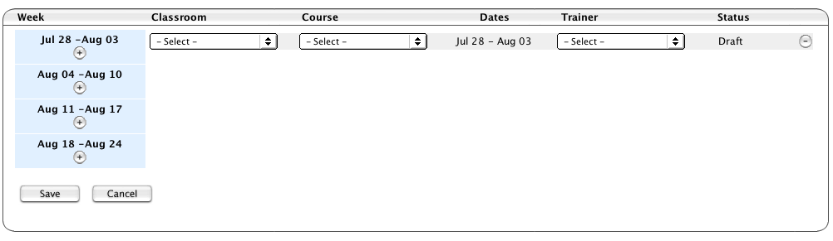
Select Classroom from the pull down menu. If your facility has more than one classroom, you will need to determine which classroom to use for your proposed training event.
Select Course from the pull down menu and choose the course you want to schedule. The menu displays only those courses your facility is authorized to deliver.
NOTE: Do not select Trainer from the pull down.
Click the Save button on the lower left portion of your screen.
WARNING: If you are proposing more than one class in the SAME classroom in any week, you must save your proposed event first and follow the next steps before proposing another class in that same week. If you do not, you will not be able to save the second class because the system defaults to Monday.

Step 5. Change Class Status from Draft to Committed
After saving your Draft proposal, you must Commit the course and Submit Schedule. To do this, click on the magnifying glass icon to the right to Commit the class.
To commit your class, you must identify an Escalation Manager, confirm or change your Start Date, change the status to Commit and Save the changes.
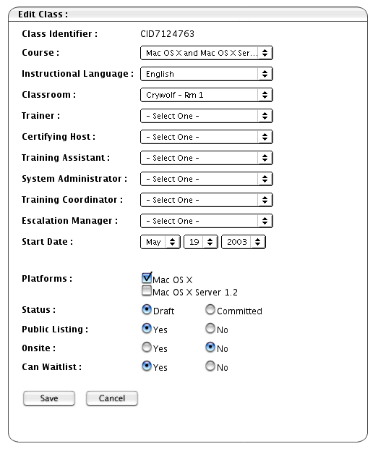
Identify your Escalation Manager. This most often will be either yourself or your dedicated trainer. Apple assigns this role in Clockwork.
Verify the Start Date of your course. Change the date if needed.
Change the Status from Draft to Committed and click on the Save button.
After saving, you will be sent back to the Master Schedule page.
Repeat this for all courses.

Step 6. Submit Schedule for Publishing
IMPORTANT – If you have proposed classes beyond the 4-week default, identify the number of weeks to be viewed and click Filter.

When you see all your proposed class(es), click the Submit Schedule button located in your lower right-hand corner. If you do not see all of your proposed classes on the screen, the classes not showing will not be submitted to Apple for approval and posting.

TIP: You can propose up to 12 weeks of classes at one time if desired EXCEPT if you are proposing more than one class in the same classroom during the same week. In these instances, you must follow Step 5. Change Class Status from Draft to Committed above before proceeding.

Step 7. Log Out
At the end of your session it is recommended that you log out of the application for security reasons. Click on the Logout tab.
After clicking on the Log Out tab, you are presented with the following screen. Clicking Yes will take you back to the Log In screen.

Canceling A Class

Canceling Class In Draft or Committed Status
To cancel in class that is still in Draft or Committed status, view the class in the Master Schedule view and click on the – button.

Canceling A Published Class
To cancel a class that is in Published status or has already been published, you must send an email at least 7 days prior to the class start date to The AATC Program Manager at trainingcenter@apple.com to Retire a specific class. Retiring the class removes a published class from the website.

Clockwork Glossary
The following terms are used within the Clockwork application. You should familiarize yourself with these terms for a better understanding of their meaning and specific application.

Class A specific training event.
Classroom A room in which classes are delivered.
Committed Status of a class that indicates a commitment to hold the class.
To Save a class as Committed, you assign:
- A Course Name
- A Classroom
- An Escalation Manager
- A Start Date
Once committed, a training class cannot be un-committed; however, it can be retired.
Course A class offering, such as Macintosh OS X Server Essentials. See Class.
Draft Status of a class not yet Committed.
Escalation Manager Person ultimately responsible for the successful execution of a particular class. The Escalation Manager is determined when you change the class status from Draft to Committed and must be identified in order to Save.
Facility Site of one or more classrooms. In the Classroom & Facilities window, Facilities can be viewed using the following filters (choosing a filter displays only those facilities that match the filter):
- Apple: Apple Facilities
- AATC: Apple Authorized Training Center Facilities
- Onsite: Facilities not open to the general public such as a customer site.
Trainer Apple Certified Instructor who is responsible for the leader-led delivery of an Apple Training course.

Winona Ordering System: An Introduction
Winona is a web-based application used to order student course materials for Worldwide Customer Training (WWCT) courses.
This document gives a basic introduction to the features and functionality of this system and walks you through the process of ordering materials for WWCT courses.

Required Winona Setup
Each AATC must identify a primary and secondary person who is authorized to order student kits and purchase on their company’s corporate credit card.
Each primary and secondary contact needs an active Apple Connect account. To order Student Course Materials using the Winona system you must be able to access the Apple Sales Web and the online Apple Training Materials Order form.
The AATC Program Manager manages access to Winona. For questions regarding AATC access to the Winona system, contact AATC Program Manager via email at trainingcenter@apple.com.

Preparing to Order Materials

Frequency, Timing & Shipment Guidelines
- Order on a weekly basis or as needed.
- Once an order is placed, it cannot be cancelled.
- Materials should be ordered two (2) weeks or ten (10) business days in advance of the class start date for ground shipping.
Note: There are increased shipping costs for priority shipping.
- Materials will ship only to your authorized training center location. Your shipping address and credit card billing address must match.

Order Information Required
You will need the following information for each order:
1. The course name or student kit part number (provided in Winona).
2. Number of student kits you wish to order.
- Type of shipping method you wish to use.
- Credit Card information.

Ordering Form Escalation
Order form questions or problems should be addressed to the AATC Program Manager via email at trainingcenter@apple.com.

Ordering Training Materials

Step 1. Log In
To log in, launch your internet browser and type the following information:

URL: sales.apple.com or asw.apple.com
At the Sign In Page, enter your:
Apple ID: Your Apple Connect ID
Password: Your Apple Connect Password
Press the Return key or click the Sign In button
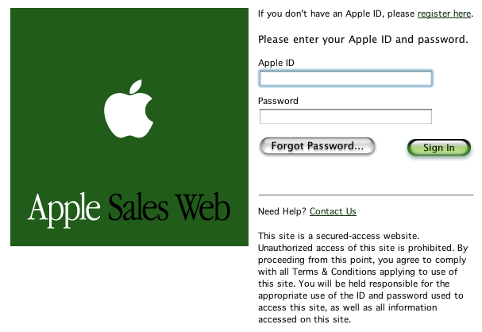

Step 2. Access Winona
To access the Training Materials Order Form, search for Winona in ASW, by typing in “Winona” and hitting the Return key or click on the Inspect Icon (magnifying glass).
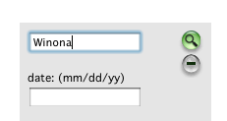

Step 3. Access the Apple Training Materials Order Form
The search results will display the Apple Training Materials Order Form. Click on the title.
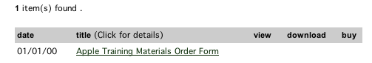

Your access will be authenticated and the order form will be displayed.
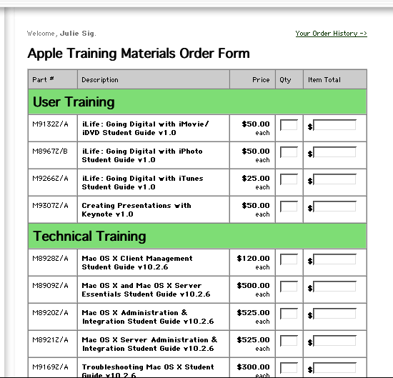

Step 4. Input Quantity and Select Shipping Method
You may use one form for multiple products. If you prefer, you may use a new order form, without repeating steps 1 to 4, for additional orders.
1. Locate the Part Number or Student Guide title in the description.
2. Type in the quantity you wish to order.
- Choose the best shipping method for your delivery needs.
- Click on the Next button.
Note: A Course Completion Certificate and Exam Voucher are included with each student kit. Additional certificates and vouchers can be ordered for US $1 each.

Step 5. Add Shipping and Payment Information; Place Order
Your order will be summarized at the top of the screen. 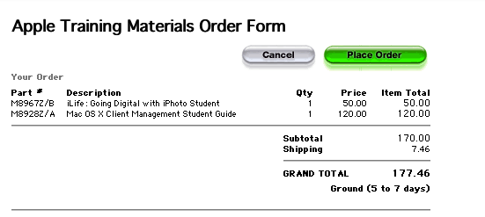
The lower section displays the Billing and Shipping information. Data associated with your Apple Connect ID is automatically populated in the shipping information fields.
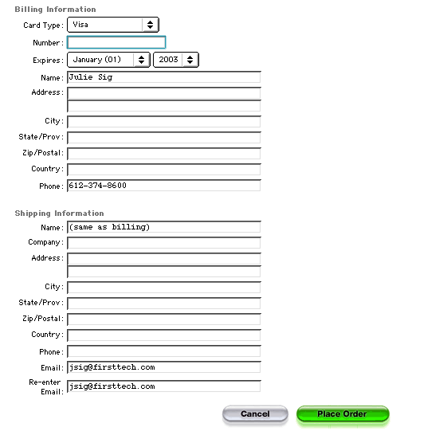
Note: Materials cannot ship to any address other than your authorized AATC location.
Enter data in all the fields and click the Place Order button.

Step 6. Order Confirmation
You will receive an order confirmation from train@apple.com immediately after you’ve placed an order. A sample order confirmation is below:

From: train@apple.com
Date: Thu, 07 Aug 2003 15:12:09 +0000 (GMT)
To: c.lopez@apple.com
Subject: your order 1000222 (carol lopez)

Order Number: 1000222
Order Date : 08-07-2003
Order Time : 8:11:59 AM

[Ship to]
Name : Carol Lopez
Company : Apple Computer, Inc.
Phone : 1-408-974-6506
Address : Apple Computer, Inc.
1 Infinite Loop
Cupertino California 95014 USA
Email : c.lopez@apple.com

[The Order]
Ship via: Second Day (2 days)

Items Ordered:
M9266Z/A iLife: Going Digital with iTunes Student qty 10
M9307Z/A Creating Presentations with Keynote v1.0 qty 8

Step 7. Shipment Confirmation
A shipment confirmation will be sent from applewwct@productorder.com when your order is shipped. Below is a sample confirmation:

From: AppleWWCT <applewwct@productorder.com>
Date: Fri, 08 Aug 2003 20:27:41 -0008
To: c.lopez@apple.com
Subject: Apple WWCT Shipment Confirmation 1000216

Your order for Apple WWCT products has shipped!
Please see below for order details.

Note: Duties and Taxes for shipments to non-US locations are the responsibility of the recipient.

Thank you again for your order.
Apple WWCT Customer Service

FedEx Tracking Number below. Please disregard the first 3 zeros
when entering your tracking number into the FedEx website.

000000634590388805
000000634590388790
000000634590388780
File name: 1000216

0040864282 . WWCTSI

Order Number: A1000216
Ship To:

CAROL LOPEZ

APPLE COMPUTER INC
1 INFINITE LOOP
APPLE COMPUTER INC
CUPERTINO, CA
95014

24 I-KIT, MAC OS X CLIENT MANAGEMENT 0.00

4 I-KIT, MAC OS X SVR ADMIN & INT 0.00

Total $: 0.00

__________________________________________________________________
Order Recap:
Total Product $: 0.00
Net Product$: 0.00
Sales Tax: 0.00
Shipping: 0.00

Grand Total: 0.00

__________________________________________________________________

NOTE: Each AATC will be charged for shipping. Your total will include shipping charges for each order you place.

Resolving Order Problems

Possible problems / Who to contact
If you have problems or questions during your ordering experience on any of the items below:

- What is the status of my order?
- I am unable to complete order online
- What is the status of my shipment?
- The material I received is incorrect.
- My order is incomplete.
- Credit card authorization has not been obtained.
- I’d like to return a product.
- I’d like to cancel an order.

Contact the AATC Program Manager via email at trainingcenter@apple.com.

Resolving Access Problems

STEP 1. Go to: http://store.apple.com

If the upper right corner of the page says: "Welcome, Your Name" then skip to step 3
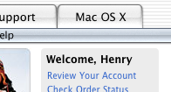

STEP 2. If it just says "Welcome" then click where it says "Sign In" and log in using your Apple Sales Web username and password:
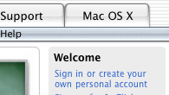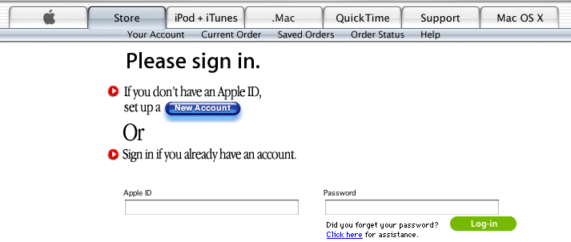

You should now see, "Welcome, Your Name":

STEP 3. Now try to access the Apple Materials Order Form by logging into http://sales.apple.com and once in, searching for keyword "aatc" then clicking on the resulting link for "Apple Training Materials Order Form"
If this *still* does not work, then continue to STEP 4.

STEP 4. Return to http://store.apple.com and verify that it says "Welcome, Your Name". Type the following in the web address field (in the URL line; DO NOT INCLUDE HTTP!): javascript:alert(document.cookie)

Your screen should look like this:
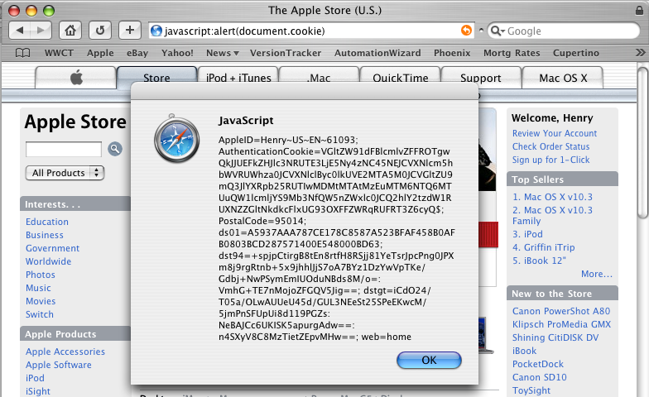

Look for the phrase "AppleID=" followed by your name, your country, the language you speak, and your "directory services ID number" (in the above example, it's 61093).

Email that AppleID to the AATC Program Manager at trainingcenter@apple.com.

Materials Ordering Glossary
The following terms are used within the Winona application. You should familiarize yourself with these terms for a better understanding of their meaning and specific application.

Apple Connect ID The account ID used to access the Apple Sales Web system.

Course A class offering, such as Macintosh OS X Server Essentials.

Course Completion Certificate Certificate given to all student attendees who have completed a specific training course.

Exam Voucher Discount coupon used by attending students to discount the cost associated with taking the associated certification exam.

Order Confirmation Email notification that your order has been received along with the details pertaining to your order.

Shipping Confirmation Email notification that your order has been shipped along with the details regarding the shipment.

Shipping Method Length of time it takes your order to arrive at your site.

Student Kit Student course materials used in a WWCT class.

Training Materials Order Form The electronic form used to order student materials.

Winona The application used to order student course materials.

Training Units 1.5 Business Processes
Apple Training Units are a way for customers to separate the purchase decision for training from the scheduling decision. The program is currently targeted at business and education institution customers. Apple Training Units are also being targeted at customers anxious to spend allocated funds within their fiscal year. This placeholder for their funds allows them to take training at a future date in order to make an educated decision about which courses are appropriate for the people involved.

With the initial success of this program, other Apple divisions and partners are looking to leverage the Worldwide Customer Training model. The program is mature enough to allow our training partners the opportunity to accept training units as a form of payment so that customers have the additional flexibility of attending Apple training at their locations.

Participation by the Apple Authorized Training Center (AATC) is entirely voluntary and based on the decision of the invididual Centers. All AATCs must read the program processes and sign an opt-in form validating that they have read and understood the program policies. This form is mandatory in order to establish a purchase order (PO). No AATC will be reimbursed without a PO in place prior to the acceptance of a Training Unit student. The opt-in form is included at the end of the Training Unit processes.

The initial forecast for this program is small, but highly strategic. Therefore, it will be necessary to rely heavily on manual processes until there is an opportunity for systems to be built to make the program truly scalable. Additionally, strict requirements must be in place to keep the revenue recognition clean.

Attached are processes around Apple Training Units for Apple Authorized Training Centers:

Training Units Redemption for Class Registration at AATC

Steps:
The customer contacts the AATC where they wish to register for a class using Training Units. Training Units can be redeemed for Apple developed training classes. A purchase order must be in place with Apple and the AATC prior to accepting a student registration.

- AATC obtains the required information from the customer for class registration
  - Course Name (Mandatory)
  - Class Start Date
  - Location, if applicable
  - Student last name, first name (Mandatory)
  - Company Name
  - Market Segment
  - Email address for Client’s Authorized Training Unit Account Administrator (Mandatory)
  - AATC information (should autopopulate)
  - Comments
- AATC submits a Training Units Redemption request to Apple (WWCT) through ASW (http://asw.apple.com/cgi-bin/WebObjects/ASWViewer.woa/wa/addBookmark?id=L308285A-US) at least 5 business days prior to class start date. Validation is done electronically based on Authorized Training Unit Account Administrator email address.
- If sufficient Training Units balance exists, Training Units will be automatically held for class and notes in the transactions note section of CrackerExtreme that this is being redeemed at an AATC, which AATC is delivering the training and the location of that AATC.
- If insufficient available Training Unit balance exists, the request will go into a hold status and an email will be auto-generated to the AATC to follow up with the Customer. Customer must either: order additional units, hold off and redeem for product using fewer units, or pay using another payment method. Split payment methods where a customer combines Training Units and another form of payment to pay for the classes are NOT allowed.
- Once a sufficient Training Unit balance is in place, CrackerExtreme will send a transaction email confirmation to Training Unit Administrator and the AATC (as well as any standard cc’s for that account i.e. Student, Account Rep). This email confirmation will serve as approval for course enrollment.

NOTES:
1) Expected turnaround time from the time of an Apple Training Unit sale to the time a student can redeem training units for a course is 7-10 business days.
2) No AATC is authorized to redeem training units from any student or company without first receiving approval from Apple (WWCT) that validates that training units are available and are being redeemed by the Company’s authorized account administrator. Any AATC who fails to obtain authorization from Apple (WWCT) validating that a student/company has sufficient training units for a class may NOT qualify to be reimbursed by Apple for delivery of the class. This decision is at Apple’s discretion. All training unit redemption requests MUST be completed prior to class start date or the AATC will not be reimbursed for the student.

Credit Process for When Customer Calls to Cancel Class at an AATC

Steps:
- Customer (Acct. Administrator) calls the AATC to cancel the class for which they have used Training Units as payment. NOTE: These refunds are subject to WWCT’s current refund policy for cancellations. If it is outside of our refund policy, this needs to be explained to the customer that they will not be receiving a credit back for the class. No further notification to WWCT is required. If it becomes a customer satisfaction issue, escalate it to WWCT.
- AATC immediately contacts TU Coordinator to advise of cancellation and rescheduling (if any) via email to Training Unit Coordinator (Operations) at trainingunits@apple.com. ANY notification must be done as soon as possible prior to class start date.
  - If customer is rescheduling for a class on a different date, the AATC needs to provide the new date and course information to WWCT’s TU Coordinator. TU Coordinator will set up new order redemption dates in PAWS.
- TU Coordinator logs into CrackerExtreme and looks for the transaction based on the Customer and date of the class.
  - If the Customer is entitled to a credit since it is within our cancellation policy, the TU Coordinator changes the status of the order from “reserved” to “cancelled.”
    - CrackerExtreme will send an automatically generated email to the customer with a cc: to the AATC and a bcc: WWCT Ops regarding the Training Units being released back into the customer’s account.
  - If the Customer is not entitled to a credit due to being outside the bounds of the cancellation policy, the TU Coordinator will leave the status of the units as is and inform the AATC. This status should remain in the “reserved” status so that the system will automatically change the status of the Training Units to “redeemed” when the first day of class occurs.

NOTE:
- All customer satisfaction issues are to be directed to Worldwide Customer Training for resolution.
- AATC will be reimbursed for the student if the student did not cancel within the timeframe required for a course credit and there are no customer satisfaction issues, even though the student did not attend the class.

Credit Process for when AATC Cancels Course at their Location

Steps:

- Course is cancelled.
- AATC contacts customer to advise of cancellation.
- AATC must contact TU Coordinator via email to trainingunits@apple.com to advise of course cancellation. ALL notifications must be done as soon as AATC makes the decision to cancel the course and as soon as possible prior to class start date. Email needs to contain the following information:
  - class name,
  - class date,
  - student name,
  - student email address,
  - company training unit account administrator email address.
- Upon receipt of this email, TU Coordinator changes the customer’s transaction status from “reserved” to “cancelled” for initial dates. If customer is rescheduling for a class on a different date, the AATC needs to provide the new date and course information.
- CrackerExtreme will send an automatically generated email to the customer with a cc: to the AATC regarding the cancellation of Training Unit transaction.

NOTE:
- Billing issues as it relates to the Customer and the AATC are to be resolved between the AATC and the customer directly.
- Participating AATCs will need to adhere to a 2 week cancellation policy if there are Training Unit Students registered to take the class. After 3 incidents where they do not adhere to the cancellation policy, the AATC will no longer be allowed to accept training units.

Payment Process for AATC redemption of Apple Training Units

Steps:
- Customer takes class at AATC using Training Units as payment.
- AATC indicates on Roster Tool which students are using TUs. Roster tool must be submited to WWCT on class start date. After 3 or more incidents of late Roster submission, the AATC will no longer be allowed to participate in the training units redemption program.
- WWCT Accounting tracks AATC and TU students based on Roster Tool submission.
- AATC invoices Austin A/P for payment and sends a duplicate copy to WWCT. Invoice should include the following information:
  - Purchase order (PO) number
  - Student’s Name
  - Company Name
  - Date of Class
  - Class Name
  - Class Part Number
  - # of Training Units
  - 80% of training class suggested retail price (see TU Redemption Price List on ASW: https://asw.apple.com/cgi-bin/WebObjects/ASWViewer.woa/wa/display?id=L307242A-US)
- ALL invoices must be submitted within 14 days of course date. WWCT Accounting to go into CrackerExtreme access rosters and student data.
- WWCT Accounting processes goods receipt (GR) towards AATC PO.
- Austin A/P processes invoice receipt (IR) on net 30 terms against PO from date of invoice submission.

NOTE:
1) Revenue recognition for WWCT will occur as normal and WWCT Accounting will accrue for the reimbursement expense.

2.) Invoices submitted that exceed 14 days from class start date are subject to non-reimbursement.

3.) Mailing address for Austin A/P is
Apple
Attn: Accounts Payable
PO Box 149114
Austin, TX 78714-9114

4.) Mailing address for WWCT is:
Apple,
Attn: AATC Program Manager
1 Infinite Loop, MS 38-1CT
Cupertino, CA 95014
Fax 408-974-2176
Email: trainingcenter@apple.com

Apple Authorized Training Center Training Units Process Acceptance Form

I, , representative of

, acknowledge that I have

read, understand, and agree that above Authorized Training Center will follow the Training Unit processes as defined by the Apple Authorize Training Center Policies and Practices document. Please sign and fax to 408-974-2176 for purchase order processing to begin.

Authorized Training Center

Signature

Printed Name

Title

Date

Apple Computer

Signature

Printed Name

Title

Date

Apple Authorized Training Center Tier Designation

I, , representative of

, acknowledge that I have

read, understand, and designate the above Authorized Training Center as a Tier participant. I understand that I may change my Tier with a subsequent submission of this same form indicating the change. Please sign and fax to 408-974-2176 ,

Authorized Training Center

Signature

Printed Name

Title

Date

Apple Computer

Signature

Printed Name

Title

Date

